Software Engineering Tools Lab

**Assignment no. 6**

Name: Gopal Shendge

PRN: 2020BTECS000061

* 1. What is Microsoft’s VSS? Provide the information of VSS tool with respect to below points:
     1. Owner/ developer
     2. Brief information/introduction
     3. Basic operations involved
     4. Advantages
     5. Disadvantages

*Ans:*

The Volume Shadow Copy Service (VSS) is a technology

included in Microsoft Windows that can create backup copies or snapshots of computer files or volumes, even when they are in use.

* + - * *Owner/Developer:* Microsoft.
      * *Brief information/introduction:*

Correctly performing backup and restore operations requires close coordination between the backup applications, the line-of-business applications that are being backed up, and the storage management hardware and

software. The Volume Shadow Copy Service (VSS), which was introduced in Windows Server® 2003, facilitates the conversation between these components to allow them to work better together. When all the components support VSS, you can use them to back up your application data without taking the applications offline.

VSS coordinates the actions that are required to create a consistent shadow copy (also known as a snapshot or a point-in-time copy) of the data that is to be backed up.

1. VSS service: Part of the Windows operating system that ensures the other components can communicate with each other properly and work together.
2. VSS requester: The software that requests the actual creation of shadow copies (or other high-level operations like importing or deleting them). Typically, this is the backup application. The Windows Server Backup utility and the System Center Data Protection Manager application are VSS requesters. Non-Microsoft® VSS requesters include nearly all backup software that runs on Windows.
3. VSS writer: The component that guarantees we have a consistent data set to back up. This is typically provided as part of a line-of-business application, such as SQL Server® or Exchange Server. VSS writers for various Windows components, such as the registry, are included with the Windows operating system. Non-Microsoft VSS writers are included with many applications for Windows that need to guarantee data consistency during back up.
4. VSS provider: The component that creates and maintains the shadow copies. This can occur in the software or in the hardware. The Windows operating system includes a VSS provider that uses copy-on-write. If you use a storage area network (SAN), it is important that you install the VSS hardware provider for the SAN, if one is provided. A hardware provider offloads the task of creating and maintaining a shadow copy from the host operating system.
   * + - *Basic operations involved:*
   1. add
   2. get
   3. checkout
   4. check in
      * + *Advantages:*
5. Data Protection: VSS helps protect against data loss by allowing users to recover files from a previous point in time, even if they were accidentally deleted or modified.
6. Improved Backup and Recovery: VSS can be used by backup applications to create consistent backups of open files and ensure that no data is lost during backup or restore operations.
7. Reduced Downtime: By creating a snapshot of a volume, VSS allows users to continue working with their files and folders while the backup process is running, reducing the downtime required for backups.
8. Compatibility: VSS is a built-in feature of Windows, making it compatible with a wide range of Windows applications and file systems.
9. Ease of Use: VSS can be easily configured and managed using Windows built-in tools or third-party software.
   * + - *Disadvantages:*
10. Limited storage capacity: VSS is designed to work with a limited amount of storage space. When the storage space runs out, VSS can cause the backup to fail, leaving the user with no backup.
11. Limited backup options: VSS has limited backup options, and it only allows users to backup the entire volume or specific files and folders. This can be problematic if the user wants to backup individual files or applications.
12. Compatibility issues: VSS may not be compatible with all applications and software, which can cause backups to fail or become corrupted.
13. Performance impact: VSS can cause a significant impact on system performance, especially during backup operations. This can result in slow system performance, making it difficult to use the computer while backups are running.
14. Dependency on other services: VSS relies on other system services, including the Microsoft Shadow Copy Provider and the Volume Shadow Copy Service writer,

which can cause issues if these services fail or are not configured correctly.

* 1. Create a SVN repository and perform below operations on that repository using SVN. Also explain below operations:

1. Revert
2. Import
3. Checkout
4. Commit
5. Update
6. Copy.

*Ans:*

* 1. Revert: Reverts any local changes to a file or directory and resolves any conflicted states. svn revert will revert not only the contents of an item in your working copy, but also any property changes.

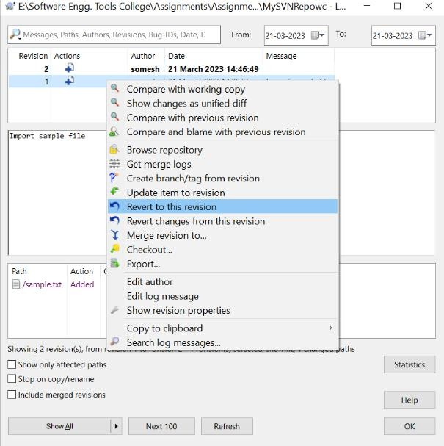

* 1. Import: Copy an unversioned tree of files into a repository, creating intermediate directories as necessary. svn import doesn't require a working copy, and your files are immediately committed to the repository.

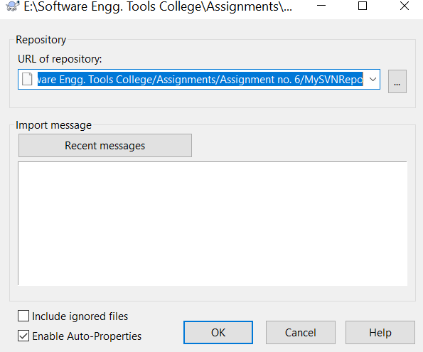

* 1. Checkout: Checks out (retrieves) a working copy of the repository into the specified folder.

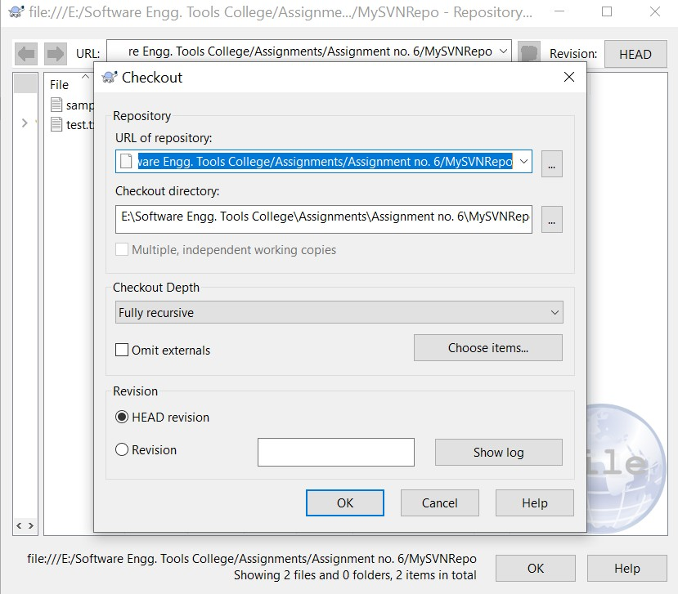

* 1. Commit: Sending the changes you made to your working copy is known as committing the changes. But before you commit you have to make sure that your working copy is up to date.

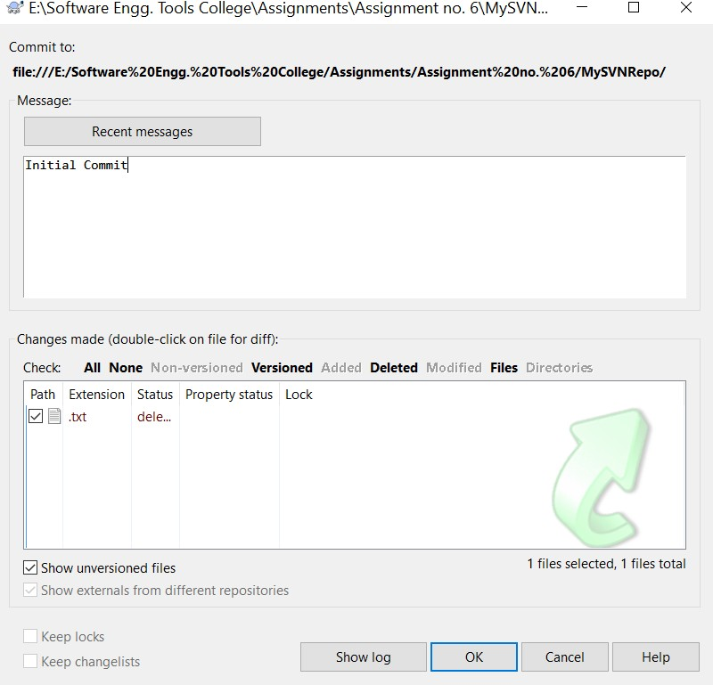

* 1. Update: Lets you refresh your locally checked out repository with any changes in the repository HEAD on the server. It also tells you what has been changed, added, deleted. If a change has been made to a file you have also changed locally, svn will try to merge those changes.

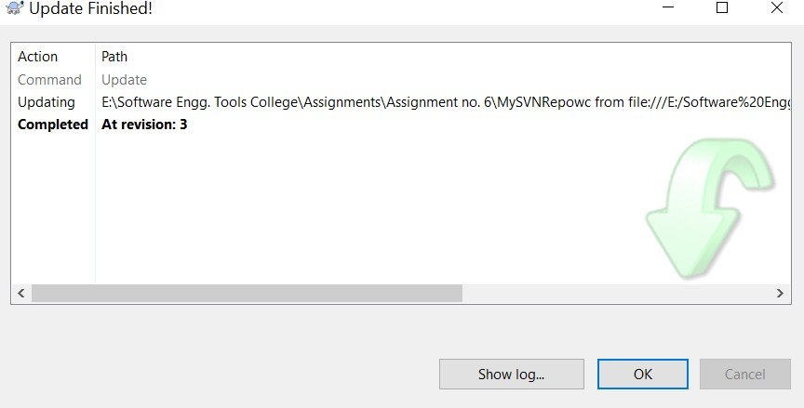

* 1. Copy: Create branches and tags. This is the same command that is used to copy items in your working copy and in the repository when you want them to be historically related.

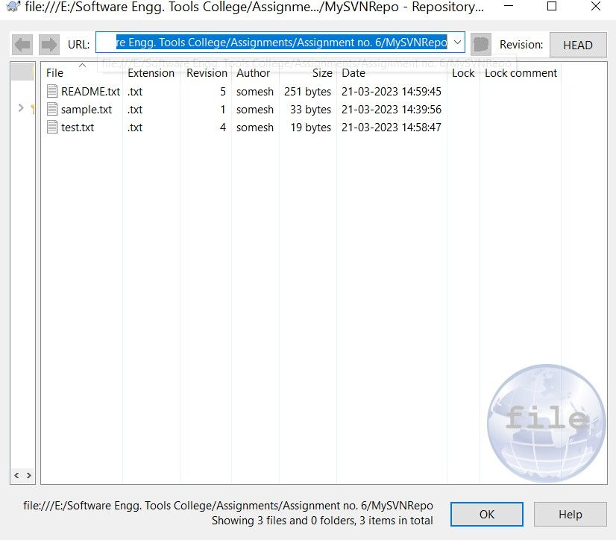

* 1. Perform below operations using CVS:



* + 1. cvs checkout
    2. cvs update
    3. cvs add
    4. cvs remove
    5. cvs commit

*Ans:*

*Creating a repository:* cvs -d "E:\Software Engg. Tools College\Assignments\Assignment no. 5\CVS Repo" init

*Creating a project:* cvs -d "E:\Software Engg. Tools College\Assignments\Assignment no. 5\CVS Repo\cvs_file" import - m "CVS START" cvs_file myfile start

1. *cvs checkout:*

cvs -d "E:\Software Engg. Tools College\Assignments\Assignment no. 5\CVS Repo\cvs_file" checkout cvs_file

1. *cvs update:*

cvs -d "E:\Software Engg. Tools College\Assignments\Assignment no. 5\CVS Repo\cvs_file" update

1. *cvs add:*

cvs -d "E:\Software Engg. Tools College\Assignments\Assignment no. 5\CVS Repo\cvs_file" add cvs_file_1



1. *cvs remove:*

cvs -d "E:\Software Engg. Tools College\Assignments\Assignment no. 5\CVS Repo\cvs_file" remove cvs_file_1

1. *cvs commit:*

cvs -d "E:\Software Engg. Tools College\Assignments\Assignment no. 5\CVS Repo\cvs_file" commit cvs_file_1

* 1. Differentiate Between The Git & SVN Repository.

*Ans:*

|  |  |
| --- | --- |
| **GIT** | **SVN** |
| Git is open source distributed vice control system developed by Linus Torvalds in 2005. It emphasis on speed and data  integrity | Apache Subversion is an open source software version and revision control system under Apache license. |
| Git has a Distributed Model. | SVN has a Centralized Model. |
| In git every user has their own copy of code on their local like their own branch. | In SVN there is central repository has working copy that also make changes and committed in central  repository. |

|  |  |
| --- | --- |
| In git we do not required any Network to perform git operation. | In SVN we required Network for runs the SVN operation. |
| Git is more difficult to learn. It has more concepts and  commands. | SVN is much easier to learn as compared to git. |
| Git deals with large number of files like binary files that change  quickly that why it become slow. | SVN control the large number of binary files easily. |
| In git we create only .git directory. | In SVN we create .svn directory in each folder. |
| It does not have good UI as compared to SVN. | SVN has simple and better user interface . |

* 1. What is “branch”, “tag” and “trunk” In SVN?

*Ans:*

1. *Branch:* A branch is a side-line of development created to make larger, experimental or disrupting work without annoying users of the trunk version. Also, branches can be used to create development lines for multiple versions of the same product, like having a place to backport bugfixes into a stable release.
2. *Tag:* tags are markers to highlight notable revisions in the history of the repository, usually things like "this was released as 1.0".
3. *Trunk:* Trunk is the main line of development in a SVN repository.
   1. How CVS is different from SVN?

*Ans:*

|  |  |
| --- | --- |
| **CVS** | **SVN** |
| It is **C**oncurrent **V**ersions **S**ystem. | It is **S**ub**V**ersio**N**. |

|  |  |
| --- | --- |
| CVS was developed by Dick Grune. | SVN was developed by CollabNet Inc. |
| It is open source and released with GNU General Public  License. | It is open source and released with Apache License. |
| CVS uses RFC format to store repository. | SVN uses binary format to store repository |
| CVS has a systematic mechanism of maintaining  tags and branches. | SVN uses branch, area and trunk to manage repository and there is  no tag feature. |
| CVS is slow as compared to SVN. | SVN is fast due to all the files are completed backed up onto  computer. |
| CVS initially requires the data to be text and asks user for the  datatype. | SVN is smart and can easily see the changes and publish that. |